**Fillmore Central School**

**2024-2025**

**Interscholastic Athletics**

TABLE OF CONTENTS

District Philosophy 1

I. Conditions of Participation 2

II. Code of Conduct 3-5

III. Due Process 6-7

IV. Related Policies 7-9

A. Academic Eligibility

B. Attendance Requirements

C. Awards

D. Bus Trips

E. Insurance Coverage

V. Student Responsibilities 10

A. Dress

B. Equipment

C. Reporting Injuries

D. Use of Building

VI. Code of Ethics 11

VII. Concussion Information 12

FCS 5139.1

STATEMENT OF PHILOSOPHY

Participation in athletics requires keen minds, healthy bodies, and high levels of training and conditioning. Individual performance and team success are dependent upon universally recognized training rules. In addition to encouraging pupils to develop their athletic skills, the district encourages and promotes sportsmanship, citizenship, and sound morals. Pupils participating in athletics have more than usual exposure to public opinion. Consequently, the actions of such pupils are more likely to be exposed to the judgment of their peers, professionals and the public. The district recognizes its obligation to encourage maximum precautions to protect the morals and reputations of the pupils. In particular, students wearing the letter of the school are uniquely identified with the school district. Their actions and behavior reflect on them as individuals and on the school district.

This athletic policy has been adopted to promote excellent sportsmanship and citizenship, to protect the health, safety and welfare of the students engaged in strenuous physical activity and to assist the students in building sound moral characters. It will advise them as to the avoidance of activities which will have an adverse impact upon their physical well-being and their moral character.

Each athlete may expect that the coach has a genuine and up-to-date knowledge of the sport, and that the coach will treat him/her fairly and without prejudice.

Athlete as used herein means a pupil participating in athletics.

It is the responsibility of each athlete to study this document and, along with a parent or guardian, sign the form on the last page. The signature indicates that the policies and the procedures have been read and will be honored by the student.

FCS 5139.1

Page 2

I. Conditions for Participation

A. Once each year every athlete must pass an approved physical examination prior to participating in any interscholastic sport by his or her family physician. Each athlete is responsible for reporting for the physical at the scheduled time.

B. If a student is unable to participate due to an injury or illness for 5 or more consecutive days, he/she must be re-examined by the school doctor before being able to begin practice again.

C. Academic eligibility, according to the Fillmore Central School policy, must be maintained.

D. All eligibility requirements of the NYSPHSAA (New York State Public High School Athletes Association) must be met. An athlete must be a bonafide student, meaning a student must be enrolled in at least four subjects, including physical education. Alternatives to this eligibility requirement are set forth by NYSPHSAA. It is the responsibility of the coach to inform the students about the age requirements and other standards set forth by NYSPHSAA.

E. The pupil must be provided with, and shall read a copy of, this athletic policy, acknowledge the receipt of same, and return a signed copy of this athletic policy to the school, signed by the pupil and a parent or guardian. Parental signature indicates awareness of this athletic policy and consent for the son/daughter to participate in the sport.

F. The Board of Education of the district is committed to the belief that its school athletes should be fit and healthy which includes abstaining from the use of alcohol or engaging in any kind of substance abuse.

FCS 5139.1

Page 3

II. Code of Conduct

A. Consumption and use of alcohol, tobacco, marijuana and recreational use of controlled substances have been determined to be adverse to good health and a possible violation of law. In order to protect the health of participants and to encourage good conditioning for successful athletic competition, the following training rules are in force on and off school property, regardless of the student's age and for the entire sports season.

1. Athletes will not smoke, use or have in their personal possession or use any tobacco products or electronic smoking device.

2. Athletes will not use or possess alcoholic beverages.

3. Athletes will not use or possess drugs. This refers to misuse of non-controlled substances(including marijuana) or in possession of controlled substances, except as prescribed by the athletes physician/doctor.

1st offense - The athlete will be dismissed from interscholastic athletic competition for 5 consecutive weeks.* The athlete will be reinstated after a 3 week dismissal if the athlete provides documentation of 3 counseling sessions with a certified substance abuse counseling agency.

2nd offense - The athlete will be dismissed from interscholastic athletic competition for 10 consecutive weeks.*

3rd offense - The athlete will be dismissed from athletics for 40 consecutive weeks.*

*Example - If an athlete is dismissed for 10 weeks on May 22 part of the dismissal will be applied to the start of the next athletic season in which the athlete participates.

FCS 5139.1

Page 4

An athlete convicted of a violation of the New York State Vehicle and Traffic Law relating to the use of alcohol while operating a motor vehicle, or convicted of violating laws relating to the use of drugs, controlled substances or alcohol, or the giving of alcohol to others shall be automatically charged as having violated this section of the athletic policy.

Any athlete convicted of a misdemeanor or a felony in areas described above or otherwise, may be dismissed from the team pending a meeting with the athletic council.

B. If a student is assigned a detention after school, that assignment takes precedence over any practice or game during that time. Students may practice or play after detention.

C. Students on school suspension (in or out-of-school) may not practice or play on the day(s) of suspension.

D. Athletes are expected to attend all practices and games unless excused by the coach. Unexcused absence from a game may result in dismissal from the team unless an emergency situation made such notification impossible. Unexcused absences from practices will be subject to the following disciplinary action:

1. First offense: The coach will confer with the athlete and notify his/her parents/guardian.
2. Second offense: The athlete will be suspended from the athletic contest following the infraction.

The parents will be notified by the coach.

1. Third offense: The athlete will be dismissed from the team. The parents will be notified by the coach.

FCS 5139.1

Page 5

E. Athletes are expected to demonstrate appropriate behavior during athletic activities and also during the regular school day.

1. Sportsmanlike behavior and ethical conduct are expected from all athletes. Athletes should demonstrate respect for coaches, officials and other team members and should show courtesy to opposing coaches and players.

2. Profanity is not permitted.

3. Insubordination to faculty members or other adults or repeated disciplinary problems in school will jeopardize the student's privilege to participate in a sport.

The disciplinary action taken as a result of inappropriate behavior as noted above is described in section D-1, 2 and 3.

F. Intentional indecent exposure may result in dismissal from the team.

G. Coaches may establish additional written rules and procedures as they deem necessary and prudent for the participation of pupils in sports ~~and cheerleading~~. Such written rules or procedures will be distributed to each member of the team at the beginning of the season along with this Athletic Policy. A copy of such written rules and procedures will be submitted to the Superintendent for Board of Education action (and also filed with the Principal and the Athletic Director) sixty days prior to the first week of the individual sports season.

H. Other Disciplinary Measures:

The Athletic Policy shall not be deemed exclusive of, or supersede any other policies or discipline codes of the school.

FCS 5139.1

Page 6

III. Due Process

A. Coaches and employees of Fillmore Central School District are to report actions of the pupils which are contrary to the athletic policy. Complaints must be made in person, and in writing, to the Coach, Athletic Director, and 7-12 Principal. Immediate investigation into the matter or incident by the Coach and Athletic Director will then follow. If more that one team is involved in a complaint, the Principal or Superintendent will confer with all Coaches involved early in the investigation.

B. Right to Hearing

At the time a pupil is advised of the information or charges which accuse the pupil of violating the athletic policy, the pupil shall also be advised that he or she has the right to have a parent or the person in parental relation to the pupil appear informally before the coach to discuss the factual situation underlying the proposed disciplinary action to be taken against the pupil. The pupil and the parent shall both be advised in writing by the 5-12 Principal of the proposed disciplinary action to be taken.

C. Appeal Procedure

A pupil or the pupil's parents may appeal the disciplinary action taken by the coach. Such appeal shall be made in writing to the Athletic Council within five days of the coach's notification to the parents. The Council shall consist of the Principal, Athletic Director, two classroom teachers and a coach. If any of these members is the coach involved in the actual appeal, an alternate will temporarily serve on the Council.

1. The request for appeal shall be addressed to the Principal.

2. The Principal shall convene the Council no later than five days after the receipt of the appeal request.

3. A hearing shall be conducted involving the Athletic Council, coach of the sport involved, witness(es)

FCS 5139.1

Page 7

to the violation, the athlete, and athlete's parents if they wish to be involved. The athlete and coach shall be allowed to testify, to have witnesses and to questions all witnesses.

4. A decision shall be reached by a majority vote of the Athletic Council, and a written notice of the results shall be sent to the athlete and the coach, with copies going to the Superintendent and members of the Athletic Council.

5. If a student is dissatisfied with the decision of the Athletic Council, the matter may be appealed in writing within five days to the Board of Education. The appeal should be directed to the Superintendent.

IV. Related Policies

A. Academic Eligibility

Athletes who are on category II of the ineligibility List (two or more failing marks with an unsatisfactory comment for each subject) are not allowed to participate unless they meet the following criteria:

1. A student may be removed from category 2 (failing two or more subjects) by obtaining the signatures of the teachers who placed them on category stating that significant progress is being made towards passing the class. If a student drops a class, a teacher may still put that student on category. There is no way to be removed from category by dropping a class. The signing for removal from category is entirely at the discretion of the teachers who placed the student on the category list.

FCS 5139.1

Page 8

B. Attendance Requirements

1. To be eligible to participate in an interscholastic competition (game, practice, scrimmage, match) an athlete must be in attendance for the entire school day (8:10 a.m. - 3:15 p.m.). Failure to do so may result in the loss of privilege to participate in that evenings event (practice or contest). The coach, Athletic Director, Principal and Superintendent reserve the right to examine each incident independently and by a case-to-case basis. The Principal or Superintendent must always give final approval. Exceptions could be made for approved medical appointments, emergency situations, and legal or excused tardiness or absence.

2. The athlete must also attend school (8:10 - 3:15 p.m.) on the day following the game to be eligible for the next scheduled practice (whether it be that day or not). Failure to do so may result in the loss of privilege to participate in the next event (practice or contest). The coach, Athletic Director, Principal and Superintendent reserve the right to examine each incident independently and by a case-to-case basis. The Principal or Superintendent must always give final approval. Exceptions could be made for approved medical appointments, emergency situations, and legal or excused tardiness or absence.

3. If a student is absent on Friday due to an unexcused absence, the student will not be eligible to participate in Saturday activities. This rule is also in effect for those shorter school weeks. For example, if there is school on Monday, Tuesday, and Wednesday, but not on Thursday, the student must be in proper attendance on Wednesday to be active in a sport on Thursday. The Principal and Superintendent reserve the right to examine each incident independently and by a case-to-case basis. The Principal or Superintendent must always give final approval.

a. **Excused**: An absence, tardiness or early departure may be excused if due to personal illness approved by the nurse or an administrator, death in the family, impassable roads due to inclement weather, religious observance, quarantine, required court appearances, attendance at clinics for mental or physical health reasons, approved college visits, approved cooperative work programs, military obligations or other such reasons as may be approved by the principal.

b. **Unexcused**: An absence, tardiness or early departure considered unexcused if the reason for the lack of attendance does not fall into the above categories (examples: family vacation, hunting, babysitting, haircut, oversleeping, etc.)

FCS 5139.1

Page 9

4. A student-athlete who is medically excused from participation in a regularly scheduled physical education class will not be allowed to participate in the interscholastic activity (practice, game, scrimmage, match) for that day.

C. Awards

Upon the recommendation of the Coach, athletes who have been on the team for 50% of the regular season are eligible for a letter or pin.

D. Bus Trips

All members of Fillmore Central School athletic teams and ~~cheerleaders~~ shall be transported both to and from athletic events outside the Fillmore Central School District by means of transportation furnished by the school district.

The athlete must ride home on the bus unless: 1)The athlete is released to the parent at the site of the games, 2) The athlete presents a note to the coach, signed by the parent, stating that the athlete may ride home with another parent of a team member, or adult family member. The note must include name of the parent or adult family member. Athletes will not be released to fellow students, boyfriends, or girlfriends.

Violation of these rules may result in the student being suspended for one game.

E. Insurance Coverage

The insurance provided by the school district is very limited, offering only secondary (not primary) coverage for injuries sustained in school related accidents. The student's family insurance is expected to provide primary or basic coverage.

Each year a description of the district's accident insurance plan is given to all students. Any questions regarding this should be addressed to the school nurse.

FCS 5139.1

Page 10

V. Student Responsibilities

A. Dress

As representatives of the school and community, student appearance is important; thus, athletes are expected to dress appropriately.

B. Equipment

Athletic uniforms are to be worn only at scheduled games and practices or unless approved by the Athletic Director and coach. Squad members are responsible for all equipment issued to them and must return all of it promptly at the coach's request.

Any athlete who fails to return all equipment issued, in satisfactory condition, as determined by coach and Athletic Director, must pay restitution before being allowed to participate in another sport. The theft, or attempted theft, of equipment will result in dismissal from the sports team currently participated in by the athlete.

C. Reporting Injuries

All injuries received while participating in athletics must be reported to the coach immediately.

D. Use of Building

During and after practice or games athletes are not to be in unauthorized areas of the building. Non-team members are not allowed in the locker rooms or the coach's office.

Athletes are encouraged to help keep the locker room clean and neat. As a guest at away games, an extra effort should be made to be respectful of the school's facilities. Locker rooms should be checked before leaving to ensure satisfactory appearance. If an athlete damages school property, whether it be another school's or Fillmore's, the athlete will be appropriately disciplined.

FCS 5139.1

Page 11

VI. Code of Ethics

IT IS THE DUTY OF ALL CONCERNED WITH HIGH SCHOOL ATHLETICS:

1. To emphasize the proper ideals of sportsmanship, ethical conduct, and fair play.

2. To eliminate all possibilities which tend to destroy the best values of the game.

3. To stress the values derived from playing the game fairly.

4. To show cordial courtesy to visiting teams and officials.

5. To respect the integrity and judgment of sports officials.

6. To achieve a thorough understanding and acceptance of the rules of the game and the standards of eligibility, including training rules.

7. To encourage leadership, use of initiative, and good judgment by the players on the team.

To recognize that the purpose of athletics is to promote the physical, mental, moral, social, and emotional well-being of the individual players.

9. To remember that an athletic contest is only a game - not a matter of life or death for player, coach, school official, fan, community, state or nation.

Adopted August 1994

Last Revised June 2006

Last Reviewed June 2010

Last Reviewed June 2011

Last Reviewed June 2012

Last Reviewed July 2013

Last Revised July 2014

Last Revised August 2015

Last Reviewed July 2016

Last Reviewed July 2017

Last Reviewed July 2018

Last Revised May 2020

Last Revised August 2022

Last Revised August 2023

**Concussions: The Invisible Injury**

**Student and Parent Information Sheet**

**Concussion definition**

A concussion is a reaction by the brain to a jolt or force that can be transmitted to the head by an impact or blow occurring anywhere on the body. Essentially a concussion results from the brain moving back and forth or twisting rapidly inside the skull.

**Facts about concussions according to the**

**Center for Disease Control (CDC)**

* An estimated 4 million people under age 19 sustain a head injury annually. Of these approximately 52,000 die and 275,000 are hospitalized.
* An estimated 300,000 sports and recreation related concussions occur each year.
* Students who have had at least one concussion are at increased risk for another concussion.

In New York State in 2009, approximately 50,500 children under the age of 19 visited the emergency room for a traumatic brain injury and of those approximately 3,000 were hospitalized.

**Requirements of School Districts**

***Education:***

• Each school coach, physical education teacher, nurse, and athletic trainer will have to complete an approved course on concussion management on a biennial basis, starting with the 2012-2013 school year.

* School coaches and physical education teachers must complete the CDC course.

(www.cdc.gov/concussion/HeadsUp/online_training.html)

* School nurses and certified athletic trainers must complete the concussion course. (http://preventingconcussions.org)

***Information:***

* Provide concussion management information and sign offwith any parental permission form.
* The concussion management and awareness information or the State Education Department’s web site must be made available on the school web site, if one exists.

***Removal from athletics:***

* Require the immediate removal from athletic activities of any pupil that has or is believed to have sustained a mild traumatic brain injury.
* No pupils will be allowed to resume athletic activity until they have been symptom free for 24 hours and have been evaluated by and received written and signed authorization from a licensed physician. For interscholastic athletics, clearance must come from the school medical director.

* Such authorization must be kept in the pupil’s permanent heath record.

* Schools shall follow directives issued by the pupil’s

treating physician.

**Symptoms**

**Symptoms of a concussion are the result of a temporary**

**change in the brain’s function.** In most cases, the symptoms of a concussion generally resolve over a short period of time; however, in some cases, symptoms will last for weeks or longer. Children and adolescents are more susceptible to concussions and take longer than adults to recover.

It is imperative that any student who is suspected of having

a concussion is removed from athletic activity (e.g. recess, PE

class, sports) and remains out of such activities until evaluated and cleared to return to activity by a physician.

Symptoms include, but are not limited to:

* Decreased or absent memory of events prior to or immediately after the injury, or difficulty retaining new information
* Confusion or appears dazed
* Headache or head pressure
* Loss of consciousness
* Balance difficulties, dizziness, or clumsy movements
* Double or blurry vision
* Sensitivity to light and/or sound
* Nausea, vomiting and/or loss of appetite
* Irritability, sadness or other changes in personality
* Feeling sluggish, foggy or light-headed
* Concentration or focusing problems
* Drowsiness
* Fatigue and/or sleep issues – sleeping more or less than usual

Students who develop any of the following signs, or if signs

and symptoms worsen, should be seen and evaluated immediately at the nearest hospital emergency room.

* Headaches that worsen
* Seizures
* Looks drowsy and/or cannot be awakened
* Repeated vomiting
* Slurred speech
* Unable to recognize people or places
* Weakness or numbing in arms or legs, facial drooping
* Unsteady gait
* Change in pupil size in one eye
* Significant irritability
* Any loss of consciousness
* Suspicion for skull fracture: blood draining from ear or

clear fluid from the nose

**State Education Department’s Guidance for Concussion Management**

Schools are advised to develop a written concussion management policy. A sample policy is available on the NYSPHSAA web site at www.nysphsaa.org. The policy should include:

* A commitment to reduce the risk of head injuries.
* A procedure and treatment plan developed by the district medical director.
* A procedure to ensure proper education for school nurses, certified athletic trainers, physical education teachers, and coaches.
* A procedure for a coordinated communication plan among appropriate staff.
* A procedure for periodic review of the concussion

management program.

**Return to Learn and Return to Play**

**protocols**

***Cognitive Rest****:* Activities students should avoid include, but are

not limited to, the following:

* Computers and video games
* Television viewing
* Texting
* Reading or writing
* Studying or homework
* Taking a test or completing significant projects
* Loud music
* Bright lights

Students may only be able to attend school for short periods of time. Accommodations may have to be made for missed tests and assignments.

***Physical Rest:*** Activities students should avoid include, but are

not limited to, the following:

* Contact and collision
* High speed, intense exercise and/or sports
* High risk for re-injury or impacts
* Any activity that results in an increased heart rate or

increased head pressure

***Return to Play Protocol:***

All return to play allowances will be handled on a case by case basis by the School Medical Doctor.

*regardless of when the student’s physician gives a date to return.

**Concussion Management Team**

Schools may, at their discretion, form a concussion management

team to implement and monitor the concussion management policy

and program. The team could include, but is not limited to, the

following:

* Students
* Parents/Guardians
* School Administrators
* Medical Director
* Private Medical Provider
* School Nurse
* Director of Physical Education and/or Athletic Director
* Certified Athletic Trainer
* Physical Education Teacher and/or Coaches
* Classroom Teachers

**Other Resources**

* New York State Education Department

http://www.p12.nysed.gov/sss/schoolhealth/schoolhealthservices

* New York State Department of Health

http://www.health.ny.gov/prevention/injury_prevention/concussion/htm

* New York State Public High School Athletic Association

www.nysphsaa.org/safety/

* Center for Disease Control and Prevention

http://cdc.gov/TraumaticBrainInjury

* National Federation of High Schools

www.nfhslearn.com – The FREE Concussion Management course does not meet education requirement.

* Child Health Plus

http://www.health.ny.gov/health_care/managed_care/consumer_guide/about_child_health_plus.htm

* Local Department of Social Services – New York State
* Department of Health

http://www.health.ny.gov/health_care/medicaid/ldss/htm

* Brain Injury Association of New York State

http://www.bianys.org

* Nationwide Children’s Hospital – Concussions in the Classroom

http://www.nationwidechildrens.org/concussions-in-theclassroom

* l Upstate University Hospital – Concussions in the Classroom

http://www.upstate.edu/pmr/healthcare/programs/concussion/classroom.php

* ESPN Video – Life Changed by Concussion

http://espn.go.com/video/clip?id=7525526&categoryid=5595394

* SportsConcussions.org

http://www.sportsconcussions.org/ibaseline/

* American Association of Neurological Surgeons

<http://www.aans.org/Patient%20Information/Conditions%20> and%20Treatment/Concussion.aspx

* Consensus Statement on Concussion in Sport – Zurich

http://sportconcussions.com/html/Zurich%20Statement.pdf

**Policy Acknowledgment/Parental Permission Form**

To be completed one time per school year. The policy will be in effect from the first practice to the last contest of each sports season of that school calendar year.

I have read the Fillmore Central School Athletic Policy and any other rules and/or procedures developed by the coach. I realize if my son/daughter does not abide by the rules set forth he/she will be disciplined in accordance to the rules and regulations.

I also hereby affirm and acknowledge that I have been fully informed of the inherent hazards and risks associated with participation, transportation of equipment related to activities, and travel to and from activity sites in which my son or daughter are engaged. With this in mind, I also hereby affirm and acknowledge that I have been fully informed of the inherent hazards and risks associated with participation, transportation of equipment related to activities, and travel to and from activity sites in which my son or daughter are engaged.

I give my son/daughter permission to compete and participate in interscholastic athletics at Fillmore Central School. Any changes to medical history should be updated each sports season to the school nurse and coach(es).

Signed______________________________ Date________________________

I have read the Fillmore Central School Athletic Policy and agree to abide by it.

Signed_______________________________ Date_______________________

Student

****************************************************************

**\*\*EMERGENCY INFORMATION/FORMS-----🡪**

**Emergency Information Sheet**

**Name___________________________________________________Grade___________**

**Address_______________________________________________Phone____________**

**Birthdate_____________________Date of Physical Exam________________________**

**Parents' Name____________________________________________________________**

**Doctor's Name_________________________________Phone_____________________**

**(Please Complete on Next Page)**

**Emergency Phone if parent not available_____________________________________**

**Hospital Name if Parent not available________________________________________**

**Allergies, medical reactions, tc.____________________________________________**

If a student has sustained an injury or has been absent from school for 5 or more consecutive days due to illness, the student must be

re-examined by the school physician before being able to practice again.

*To be eligible to participate, complete the Athletic Registration online as well as enter all applicable information into the SNAP health portal.

SNAP Portal: https://www.studentehr.com

On the following pages, you will find the NYSED Interval Health History for Athletics. If there are any changes to the student’s health history, please complete and submit this form to the FCS Health office immediately.

Updated: August 2023

Summer 2023

Dear Parents/Guardians,

The [Dominic Murray Sudden Cardiac Arrest Prevention Act](https://www.nysenate.gov/legislation/bills/2021/S1016#:~:text=On%20October%205th%2C%202009%2C%20Dominic,unrecognized%20by%20all%20around%20him) is a new law as of July 1, 2022. This law requires schools, students, and parents/guardians have information on sudden cardiac arrest risks, signs, and symptoms. Please note that sudden cardiac arrest in children and youth is rare. The incidence of sudden cardiac death (SCD) on the playing field is 0.61 in 100,000.1

Sudden Cardiac Arrest (SCA) is an emergency that happens when the heart suddenly stops working. SCA can cause death if not treated immediately, and even with treatment death may occur. Immediate treatment is cardiopulmonary resuscitation (CPR) and use of an automatic external defibrillator (AED). All public schools must have a staff member trained in the use of CPR and AED in school and at all school athletic events.

Preventing SCA before it happens is the best way to save a life[1]. Both your family health history and your child’s personal history must be told to healthcare providers to help them know if your child is at risk for sudden cardiac arrest. Ask your child if they are having any of the symptoms listed below and tell a healthcare provider. Know your family history and tell a healthcare provider of any risk factors listed below.

**The signs or symptoms are:**

* Fainting or seizure, especially during or right after exercise or with excitement or startled
* Racing heart, palpitations, or irregular heartbeat
* Dizziness, lightheadedness, or extreme fatigue with exercise
* Chest pain or discomfort with exercise
* Excessive shortness of breath during exercise
* Excessive, unexpected fatigue during or after exercise

**Student’s Personal Risk Factors are:**

* Use of diet pills, performance-enhancing supplements, energy drinks, or drugs such as cocaine, inhalants, or “recreational” drugs.[2]
* Elevated blood pressure or cholesterol
* History of health care provider ordered test(s) for heart related issues

**Student’s Family History Risk Factors are:**

* Family history of known heart abnormalities or sudden death before 50 years of age
* Family members with *unexplained* fainting, seizures, drowning, near drowning or car accidents before 50 years of age
* Structural heart abnormality, repaired or unrepaired
* Any relative diagnosed with the following conditions:
* Enlarged Heart/ Hypertrophic Cardiomyopathy/Dilated Cardiomyopathy
* Arrhythmogenic Right Ventricular Cardiomyopathy
* Heart rhythm problems, long or short QT interval
* Brugada Syndrome
* Catecholaminergic Ventricular Tachycardia
* Marfan Syndrome- aortic rupture
* Heart attack at 50 years or younger
* Pacemaker or implanted cardiac defibrillator (ICD)

SCA in students at risk can be triggered by athletic activities. To decrease any chance of SCA in a student, the [[Interval Health History for Athletics](https://www.p12.nysed.gov/sss/documents/SampleRecommendedNYSEDIntervalHealthHistoryforAthleticsFillable6.2022.pdf)](https://www.p12.nysed.gov/sss/documents/SampleRecommendedNYSEDIntervalHealthHistoryforAthleticsFillable6.2022.pdf) must be completed and signed by a parent/guardian before each sports season unless a physical examination has been conducted within 30 days before the start of the season. This form has questions to help identify changes since the last physical examination or health history was completed. School personnel may require a student with health or history changes to see a healthcare provider before participating in athletics.

Finally, the law requires any student who has signs and symptoms of pending SCA be removed from athletic activity until seen by a **physician**. The physician must provide written clearance to the school for the student to be able to return to athletics.

Please contact the State Education Department’s Office of Student Support Services for questions at [studentsupportservices@nysed.gov](mailto:studentsupportservices@nysed.gov) or 518-486-6090.

On the following pages, you will find the NYSED Interval Health History for Athletics. Please only complete this form if your child has not had their mandatory physical within the past 30 days.

By signing this document or completing the online registration form, you will agree to update any changes to your child’s health history immediately by calling the Nurse’s Office at Fillmore Central School.

Signature: __________________________________________________________

Date: _______________________________



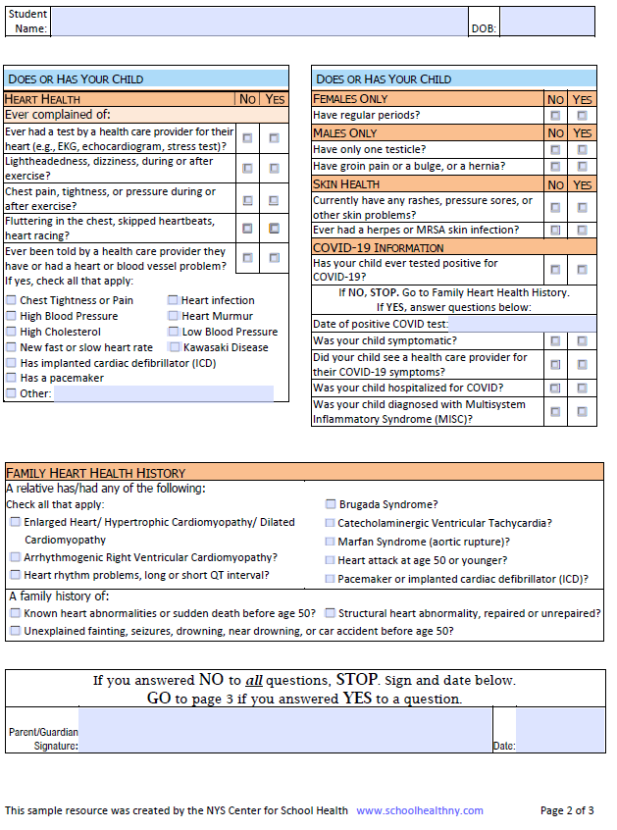

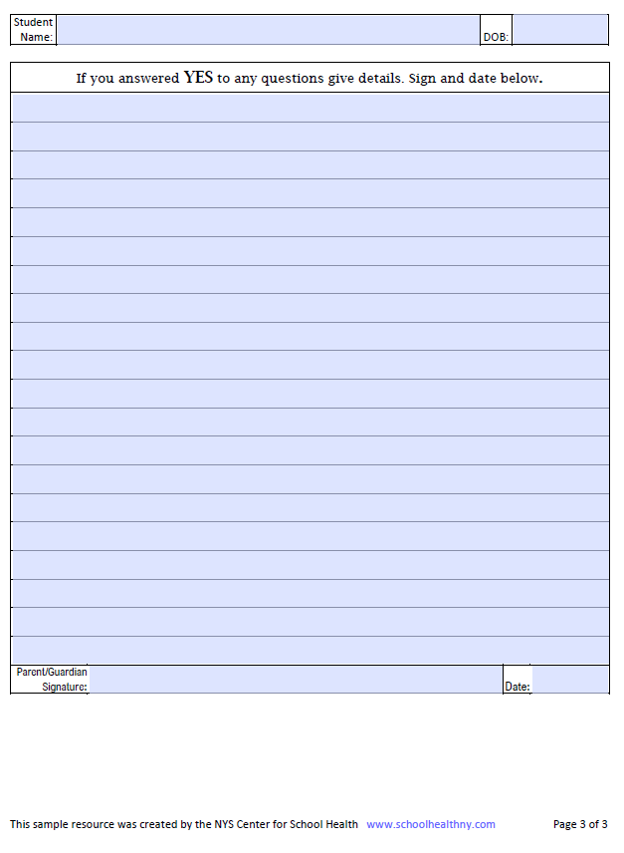

1. Maron BJ, Doerer JJ, Haas TS, et al. Sudden deaths in young competitive athletes: analysis of 1866 deaths in the United States, 1980-2006. *Circulation* 2009;119:1085-92. 10.1161/CIRCULATIONAHA.108.804617
2. [SCA Prevention Toolkit – Eric Paredes Save A Life Foundation (epsavealife.org)](https://epsavealife.org/resources/sca-prevention-toolkit/)